SEnuke X Basic Guide
Tested on SEnuke X V1.1.13

What Is SEnuke? It’s a very advanced piece of when SEO software that can perform miracles with your website rankings. However with any advanced piece of software there is a steep learning curve and up until now there has not been any easy to understand step-by-step introductions.
You can actually use SEnuke X in a variety of different ways, and this basic guide only covers the way most people start using it. You will find more basic methods on SEnuke-X.info, along with an entire section detailing more advanced methods such as server side image rotations, linkpushing, image spins and more. In addition this guide shows you ‘how’ but does not really explain ‘why’, that too will be covered in the advanced sections of our site.
After going through this guide, you will very understand how to properly start and configure SEnuke X, then create accounts and then post to them. The whole idea is to get you up and running in the shortest amount of time possible so that you can get building your first back links straight away.
Make sure that this is the first guide that you follow so I can show you how to master the basics before we move on to some more advanced tactics.

Project Planning
Prior preparation is the key to the success of any campaign in Internet marketing. We are going to show you now how to do the very basic planning for your projects.
If you have read through our ‘What Is SEnuke X’ section on the website you will know that we recommend you get yourself ready before you take out an SEnuke X trial. Ideally you are going to need:

Website
It is possible to operate with SEnuke X and no website, however I would not class that as something a beginner should do. If you don’t have an actual website yet then at least go and create a Hubpage or Squidoo Lense to promote. If you do have a site then create a list of your URL’s that you are planning to promote up the search engine results pages (SERPS).
For each URL you will also need to know what keywords you are going to promote, these should directly relate to the content on that page. Many SEO experts will tell you that you MUST include those keywords on the page. It is certainly true that it is easier to rank a site if they keywords are included. However it is not essential, as we shall prove in this guide.

Articles
Articles are the content for the sites you will be creating with SEnuke X, you are going to need at least 1 and ideally 2 or more to complete this guide. The more you have the better. The quality and uniqueness of the articles can directly determine the success of your campaigns. Quality content is less likely to get deleted, and it also stands a better chance of being ranked in its own right. However if this is your first time with X then you can just ‘borrow’ content from somewhere (such as Ezine). There is no point wasting time on your own articles until you are completely sure of what you are doing.

Our Demonstration Website:
It is important to ensure that the website that you are promoting is setup in the correct manner. If it is not setup properly or the content is not of a good enough standard then there is really no point at all throwing high quality links at it from SENuke X.
As an example I will be promoting a site called Global SMTP. The address is http://globalsmtp.info/

The site is a cheap .info domain which can be brought for as low as 98 cents from GoDaddy. It is a very basic HTML page with minimal writing. We will be showing you how we can use SEnuke X to rank the site for a keyword that the page is not at all optimised for through the power of quality backlinks. We are doing this to prove that you do not need stacks of unique content to rank for a particular keyword. In this

case the keyword is one that ranks “Easy” in the SEnuke X keyword research tool, something we will cover on the website.
While this little experiment goes against everything you may have read about SEO, it is just to prove that the power of SEnuke X can help you rank for keywords that you may not of optimized for.
Firstly what is the page about? The product on offer is a Clickbank product that allows people to send emails from wherever they are. You might not know this but mail servers are fussy beasts, and the free ones you get from your ISP do not generally allow you to send emails from a computer that is not connected to their network. These days this is not such a big issue, what with GMAIL and Yahoo Mail all offering free access from anywhere, however there are still people who need this service. The number 1 supplier of these private SMTP servers is AuthSMTP, in fact I have an account with them myself. However we are promoting one of their rivals SMTP2Go.
Now because this is a small niche these days the most common search term is for AuthSMTP, as people know that they are one of the few companies out their still offering secure SMTP servers. So we will be ranking the page for the term ‘authsmtp alternative’. If you go look at the website in question you will see the word ‘authsmtp’ is never mentioned and ‘alternative’ is only mentioned in the meta tags. However a quick Google on 9th July 2011 shows:
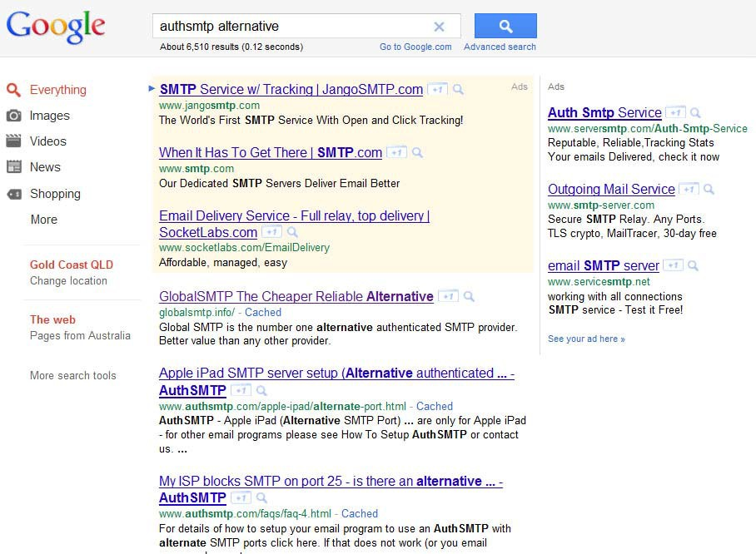
The first non-sponsored site is our site, so we have ranked for a term that does not even exist on the page.

How On Earth Is That Done?
Put bluntly, quality links followed by more links and then a few extra links added on top!
To understand how this is all going to work we need to think about how this would all be done if we were to do everything manually.
Doing it all manually would be a lot of hard work but with SEnuke X it makes our life a lot easier by doing all of the hard work for us.
So here we go
- Create our accounts on blogging sites (Web2.0) and article directories.
- Verify the created accounts. These sites all ask for email verification to ensure that they are not used by spammers.
- Once we have fully created these accounts we then need to take our articles and submit them to the created sites.
- Harvest all of the URL’s that have been created by these blogging sites. The majority of all the Web2.0 sites will also create an RSS feed for our posts which we will also collect and use later on.
- We will then submit the harvested URL’s to some of the top social bookmarking sites on the internet. These are used to help get your sites indexed quickly. Google scours these sites frequently for new URL’s and this way we can get our sites indexed far quicker than if we just let them get indexed naturally.
- Do our best to ensure everything gets indexed, by pinging, backlinking or any other means at our disposal
Always remember that everything we do here is nothing that could not be done manually. SEnuke X just automates the jobs to give us time to do other things. If we were to do everything above completely manually then it would be the best part of a day’s work. With SEnuke X it can do the entirelist in a matter of minutes.

Getting The Right Articles For The Job
Now, while we can always spin any articles that we find over the internet and make them ‘unique’ to us, you will find that all round better results are found if you have your own written articles.
If you are writing articles on a niche you are not completely up to speed with, just call up an few articles from places like ezinearticles.com and see how other people have written there articles on the niche. You can then re-write these articles in a few minutes.
Remember, when you have 1 well written article and we then spin it manually using a great spinner like TheBestSpinner.com then that 1 article can go a very long way. Now whether you should spin or not is open to great debate, I would suggest in your first nukes you don’t bother as it will use up time which is better spent getting things right.
If you like you can always outsource your article writing to contractors on sites such as Odesk, Amazon Mturk or freelancer. The list goes on.

Once you have an article ready then we can get going. Now for the main bits you have been waiting for.

Start SEnuke X
There are three ways you can create projects in X, you can use the Wizard, you can do them by hand or you can combine the two. Using the wizard is the easiest by far, and it’s what most people do to start with. However when working with the wizard you will not learn how X actually works. Equally combining the wizard with manual creation is really for power users, and as such will be covered in advanced tutorials. Thus this example we are going to be running through the campaign the manual way. By doing it manually you will be learning the backbone of SEnuke X and it actually will make your life easier in the long run when you know what is going on.

Configuring SEnuke X
We need to setup SEnuke X properly first, what I am going to show you here are not the fastest settings for X, they are however stable settings. During your first runs you don’t want things to go wrong, you have enough other things to worry about.
So click on ‘Options’ and setup as follows:
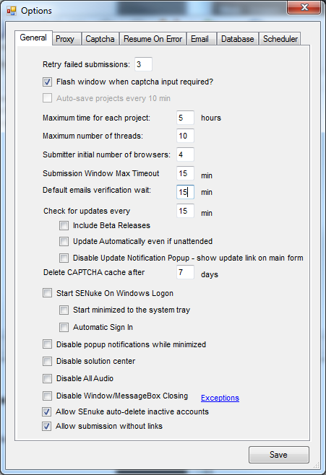
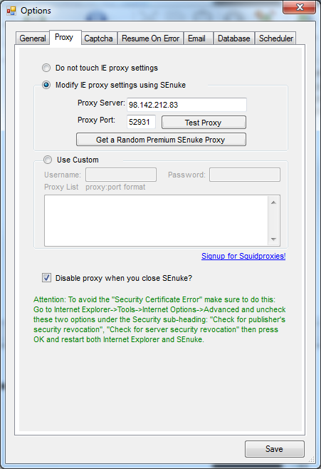
I also suggest you go to the Captcha page and get yourself a Captcha account and tick ‘Enable auto-captcha solving’. At the time of writing this the inbuilt SEnuke X Captcha service is not running yet, but it expected to be released very soon.

You can see above we are using an SEnuke proxy, what is this? Every device connected to the Internet has an IP address, this is effectively your address online much the same as your house has a street address. Everything you do on the Internet will have this IP address logged against it, so if you create an account with Gmail your IP will be recorded. If you create 100 accounts they will see your IP 100 times. Owing to the nature of SEnuke X you will be creating a lot of accounts in a lot of places, so it is possible your IP will get flagged at some of these places and you may get a ban from that site. I stress this is very rare. A proxy server gives you a different IP, data is sent from your computer to the proxy server and then from there to its destination. By using multiple proxy servers you can reduce the possibility of being noticed, and thus decrease the chances of getting any bans. Personally I almost never use a proxy server, but as most new users are quite worried I suggest you either turn on the built in one, or get yourself some private proxies.
OK on with the show.

Step 1 – Start A New Campaign
To start our manual project we first need to create a Campaign. To do this click on ‘New’ Button and Click ‘Campaign’
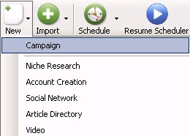
You may be wondering why you are creating a campaign! Well think of the Campaign Tab as you filing system and everything related to this campaign will be stored in that campaign file.
Literally everything can be placed in easy access from creating your accounts all the way up to submitting your finished articles to the Xindexer.
You can easily sort the filing system out into Campaigns and Sub-Campaigns.
For instance, if you had a main campaign which was aimed at the main page of the site and each sub-campaign could be aimed at internal pages of your site. This will all be covered later.
The example site we are using is http://www.globalsmtp.info/
We are going to show you how we can use the Power of SEnuke X to help rank a website for a keyword that it is not even optimized for.
The keyword we are going to be targeting is Authsmtp Alternative. You will notice that looking at the site that it is not in any way optimized for that keyword.

OK, let’s go ahead and create a campaign.
I am going to call this campaign Global SMTP. It is just a reference to the website so I know what is in the folder but the name is irrelevant to anything that we will actually be doing.
Fill in the name and select the Root Campaign tick box, if you do not tick the box it will create a sub-campaign for whatever campaign is already highlighted. Then Click ‘Save Campaign’
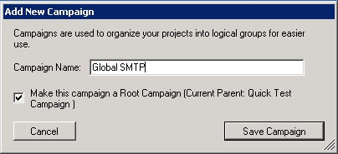
Ok, now we have our campaign folder set up we can start creating some accounts.
There is a set routine that we will need to follow to do this effectively and ensure that we get maximum possible success rate.
The sequence we will use goes like this:-
- Create An Email Address
- Create and verify all the required accounts
- Submit our article to all the relevant accounts and then harvest all your created URL’s and RSS feeds.
- Bookmark all the URL’s
- Post All The RSS Feeds to the RSS Aggregators.
- Send everything to xIndexer (Not available in the free trial)
- Post articles to article sites
Now you know what we need to do I will show you exactly how we are going to do it.
You may wonder why article posting is at the end, this is simply because at the moment this module only generates a limited number of URLs, thus it’s easier just to slip it in after everything else is done. Don’t however dismiss this module, while it may not generate you a great URL list it could still generate you a nice big profit!

Step 2 Create Email Address And Associated Accounts
Ok, now we are going to start using SEnuke X and you will start to see how quickly it creates accounts.
First we need the account creation project. Click New, then Account Creation
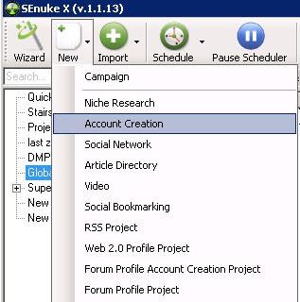

Once you have created the account you get the chance to rename it to something that is easier to remember. In this case I have called it Global SMTP Accounts

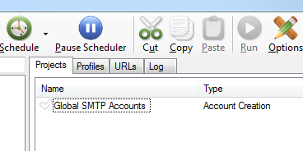

Now you have renamed your account, double click on the project

You will have a screen that looks like this :-
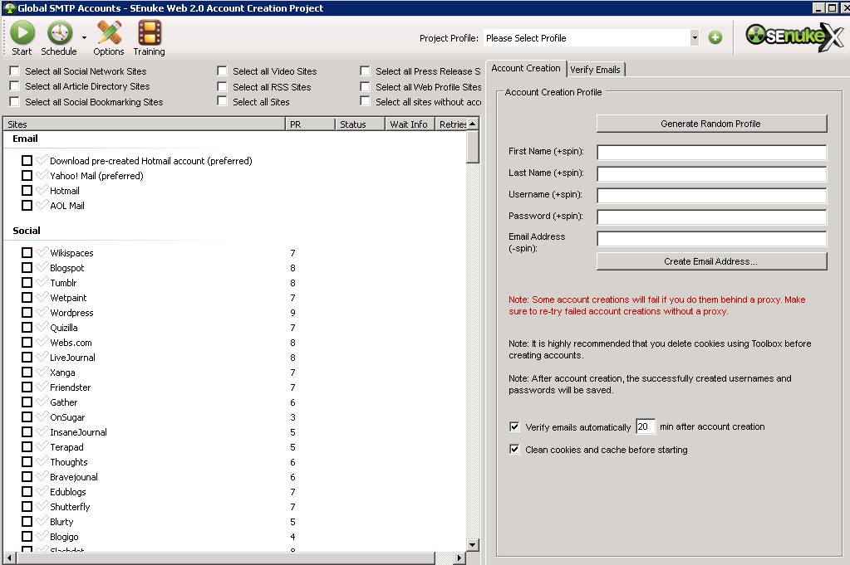

SEnuke X is designed to be easy to use so all we have to do now is fill in the boxes.
- You need to click the button that says Generate Random Profile
- Then click the + sign next to select profile. Add a name for the project, a default name will already be input. You can either use this default or fill in the box and click save.
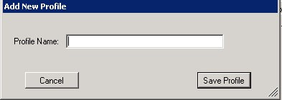

- Now to set up the email account, it is easiest to use pre-created Hotmail Accounts.

To get your email address press the Create Email Address Button

Now you will see a menu appear below the button and press the Download Pre-Created Hotmail Account.
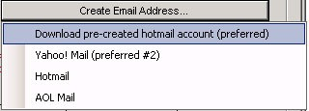

SENuke X will then start the submitter automatically and setup your email account. When it is finished the whole screen will turn blue.
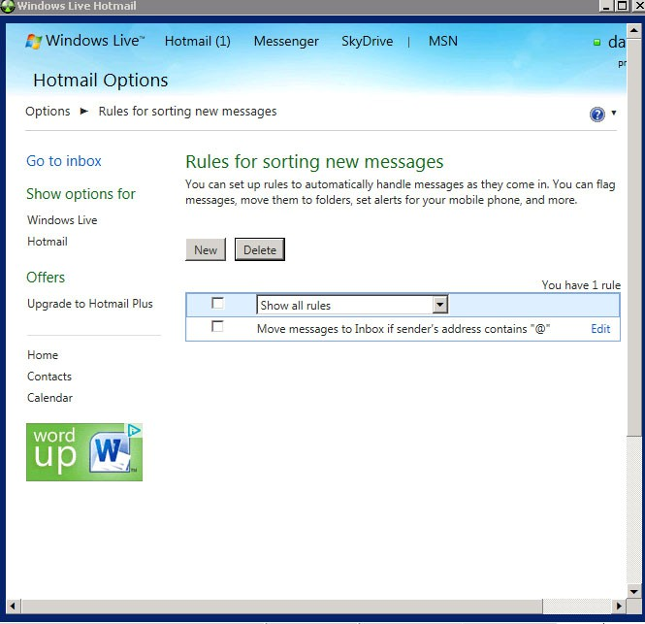
SEnuke X adds in a special rule to your email box that stops messages being marked as spam.

Now that your email address is all downloaded and your accounts creation project is all ready to go your account box should look something like this :-
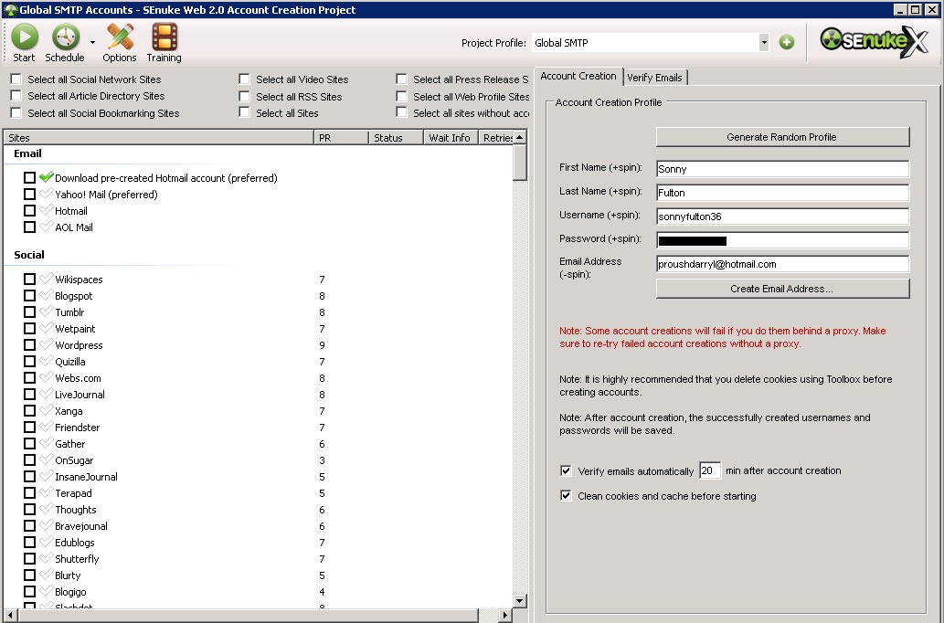

Ensure there is a tick in ‘Clean cookies and cache before starting’
Then we need to create accounts for Web2.0, Article Directory, Bookmarking Sites and also RSS Aggregators.
Tick the selection boxes at the top of the screen as shown here.

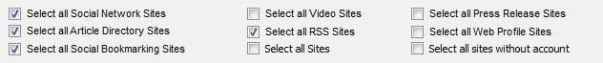

Notice we are not bothering with the Web Profile Sites, these are so heavily abused within SEnuke X community that I personally don’t find them of much use.

Preparing Our Articles
The articles which we will use will be what ‘Power’ our whole campaign. The reason I say this is that the articles which we will publish will be filled with links that point to our sites. It is these links that will be giving us our Google rankings.
By this point here you will need to have your articles to hand. If you do not have them yet then you need to go away and knock up, or ‘borrow, a few articles that you can use for this project.
Ok, now you have your articles then we are set to go for the next stage.
Firstly you need to create a new social network project. This is done by pressing the ‘New’ button on the main toolbar and then clicking Social network as shown in the picture below.
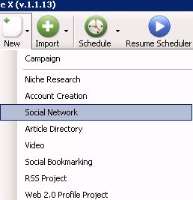

Once you have created the project you can then rename it to anything you please to make it easier for you to understand what is in the project.
In this case I have called it ‘Global SMTP Blogs’
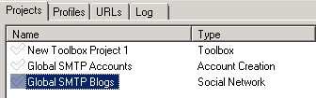

Now we are all at the same level you need to now double click on the project and you will be presented with the project window as shown below and we will go about setting it up with your article.
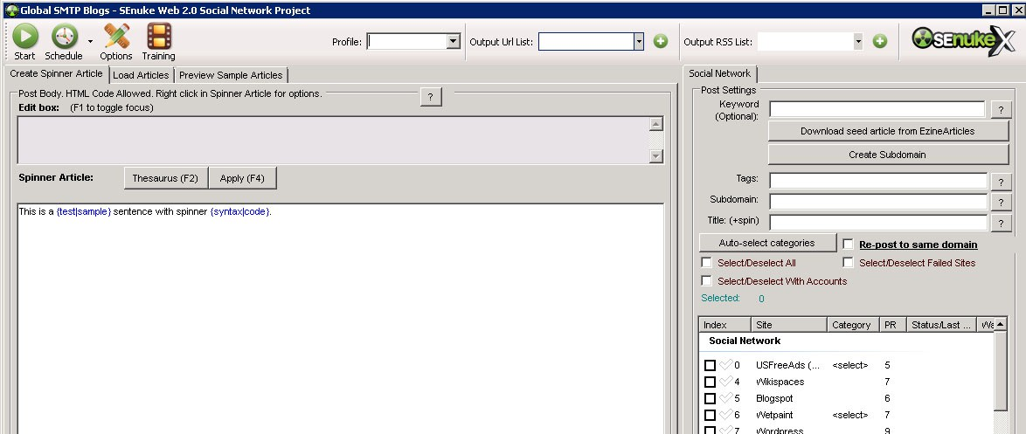

Social Networking / Blogging sites are sites where there owners let us place our articles and manipulate there sites to be more of a webpage than an article.
The benefit of this is that we can add links throughout the article whereas with article submissions the majority of sites will only allow the links to be placed within the author bio area.
Another major benefit of Web2.0 is that we can also throw in images which are great for grabbing users attention, we will have a section on images on the SEnuke-X.info website soon.
Ok, so let’s get started preparing your article for submission to the Social Networks.
Firstly, cut and paste your article into the main article area on the left of the project window.
Then we need to start filling in the gaps that are to the right of the project window which is shown below.
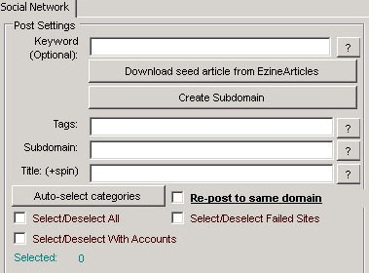
The information in here is very easy to fill out.
First of all put your main keyword into the top line. In this case it is ‘AuthSMTP Alternative’.

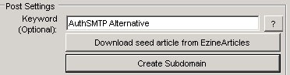
Next click the Create Subdomain button.
This will then create a domain name for your blog which incorporates your keyword.
Tags is a place to put your keyword and keyword variations, like:
Authsmtp alternative,authsmtp alternatives, authsmtp
You will then need to fill in the title. You can manually do this or if you are choosing to auto spin then you just need to sign up to The Best Spinner and fill in your details. This will be covered in another guide.
It is really simple to create a title manually though, below here is a very basic example of how to spin a few different titles that will be picked at random by SEnuke X to place with each of your submissions.
{Find An AuthSMTP Alternative|Where You Can Get An AuthSMTP Alternative|Is there A Good AuthSMTP Alternative}
The more differing titles you use the more this counts towards the uniqueness of the article. It should now look something like this:
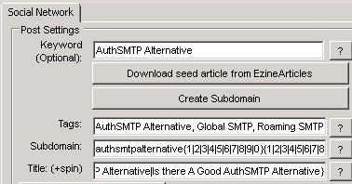

Now in this example I have already said we are not going to spin the article itself. Spinning takes a long time, and auto-spinning produces garbage that is going to get deleted.
For this project we are using SEnuke X for backlinking purposes rather than trying to rank the pages themselves. In fact in this case I want people to visit my site and not the social network sites. But I still want to collect the link juice (oh how I hate that term!) from them.
If I was trying to dominate a page of Google and wanted to get people to view the pages I was making then I would either spin the content well by hand or use multiple unique articles and each page would then be viewed as unique content and indexed as such.
So long story short, in this case we are not spinning the article. What we do need to do to the article though is to add some links.
This is made very simple with SEnuke X and you do not need to worry about inserting HTML into the article as SEnuke X will do all this for you and this is how we do it. If you want to know how to build these links yourself it is included in the basics section of SENuke-X.info.
Your keywords are the ones we want to use as Anchor Text.
So I assume that you article will be keyword optimised to some extent which means you can add some links in.
Firstly highlight the words you want to use as your anchor text. In this case it is ‘AuthSMTP Alternative’ as that’s the keyword we are targetting.
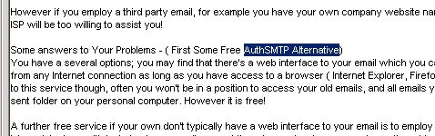
You then need to right click your mouse over the highlighted words and then click ‘add link to selected anchor text’.
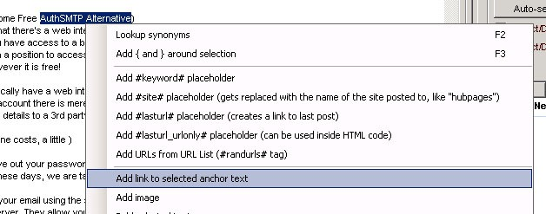

Once you do this you will be presented with a small box where you must enter the url of the site you want the anchor text to point too.
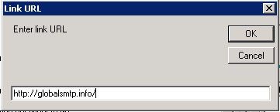
Once you click ok then the program will automatically add the HTML code to the article for you. When it is submitted this html will become a clickable hyperlink.
Once you have placed your links in (I recommend around 2 to 3, normally 2 pointing to specific sub page and 1 pointing to the homepage), then fill in the gaps at the top bar like below.
You just select the profile you want to use (in this case Global SMTP) and then call the url and rss lists whatever you like by clicking on the + symbol and typing in a name The profile is where Social Network nuke is going to get the login details for each site, the details which will be created by Step 1 earlier. The output lists are where the project will save the list of links generated by this project so future modules can use them. Confusing? Stick with it and it will all click in to place!

The final part to set up for the social networks is to select all accounts and then select categories for the sites that require them as shown in the picture below.
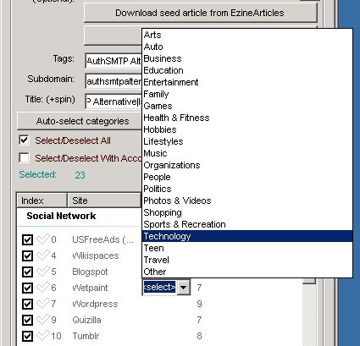

Either do this by hand or use the ‘Auto-Select categories’, because there are so few sites in Social Network nuke that require categories I find it quicker to do it by hand.
So that we don’t have to sit in front of the computer while our nuke is in progress we are going to schedule everything to run one after the other.
First of all you will need to open the scheduler.
This is done by clicking the ‘Schedule’ button on the main toolbar and then clicking Schedule project. This is highlighted in the picture below.
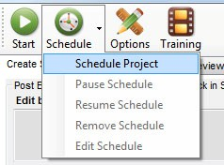

Once this is done you will see the scheduler control panel appear.
With the scheduler you can schedule projects to start at a certain date and time. At the moment we are going to set it up to run the Social Network nuke directly after we have run the account creation.
We want to tick the box that says start the project after the ‘Global SMTP Accounts’ is complete (as shown below). Once it is set up as below then just click the save button.
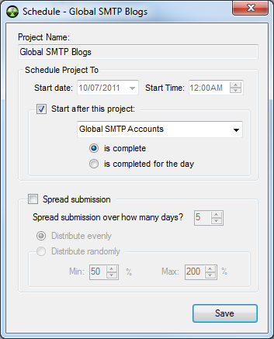

Step 3 Bookmarking
Now we need to set up the Social Bookmarking project which will bookmark all of the urls that will be harvested from the submissions process in Social Network nuke.
Click New and then Social Bookmarking
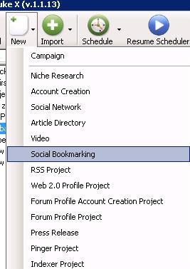
Again rename and double click on the project and we will fill in the gaps in the project window.
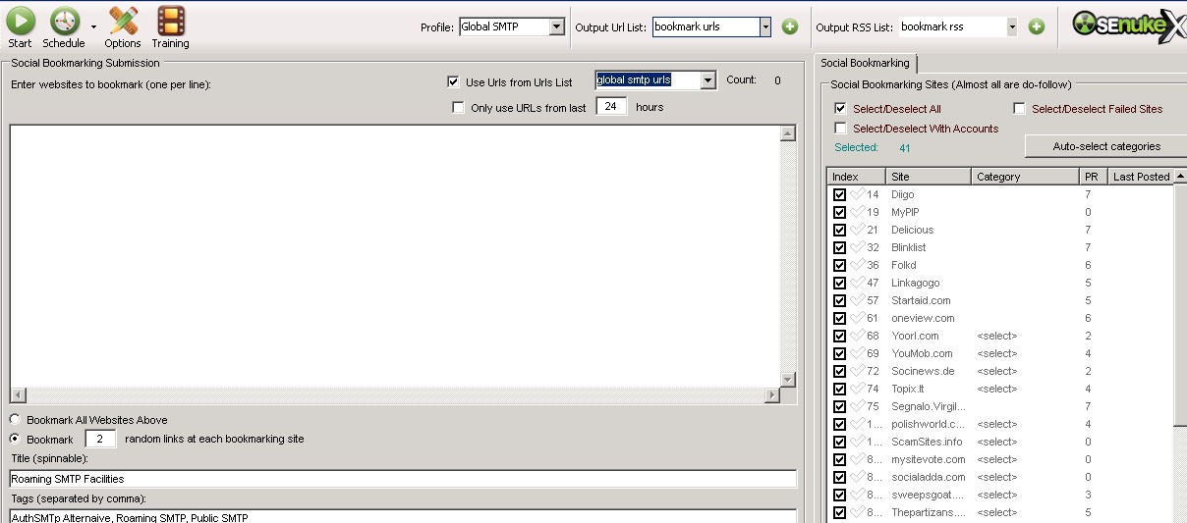
With his module it is very simple compared to the Social Network.
Firstly, on the top toolbar select the profile you want to use and then press the + button next to urls and RSS and give each one a name.

Fill in a Title, add some tags and put a small description in.
Now add a tick to ‘Select/Deselect ALL’ sites and select the categories that you want them submitted too. In this case it’s easier to use the auto select tool:
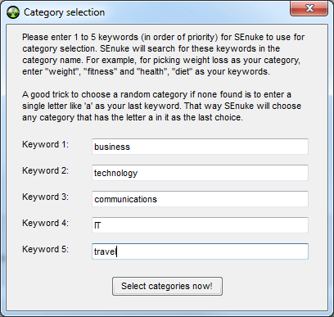

Simply fill in the keyword areas with the themes you keyword relates to, in this case sending emails while travelling on business. Then click ‘Select categories now!’
Finally select where you want to draw the urls from to bookmark. In this case I have selected Global SMTP urls as this was the name I gave to the urls list in the social network project we just created in Step 2.

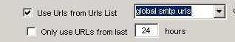

As we have done previously we need to schedule this to run after the social network project which we called ‘Global SMTP Blogs’.

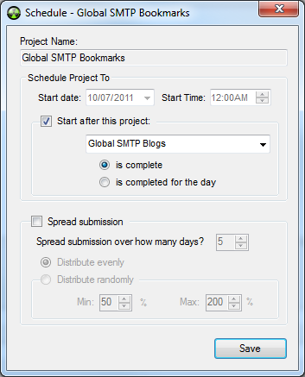

Step 4 Setup the RSS Project.
This is going to take the RSS feeds from the social network as well as the bookmarking submissions and then submit them to the RSS aggregators.
So, the same as the past few projects, click new and then RSS Project.
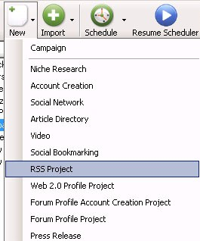
After you have done this, double click and open the project window.
The boxes are all but the same to fill in as the social bookmarking project we just completed in Step 3.
Fill in the boxes and put the tick in the box for use urls from, and then pick the RSS output from the social network project, which we called ‘global smtp rss’:
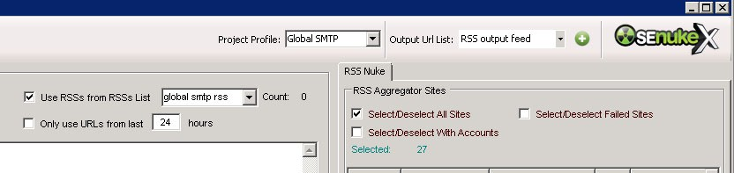

Now again, just the same as the other projects you need to add the scheduler to run after the bookmarking project.
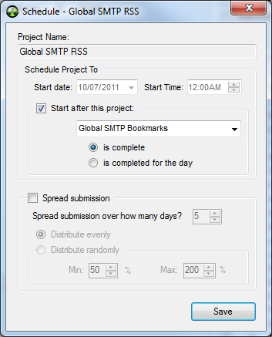

Step 5 Now Index Everything
If you are using the trial version of SEnuke X you must skip this as the module is not activated until after you have a paid subscription.
Again go to ‘New’ and this time select ‘Indexer Project’

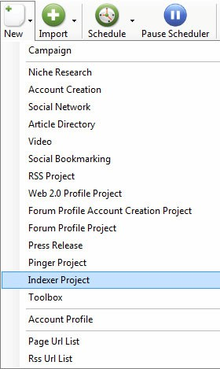

As always you can be neat and tidy and rename this project, or just leave it as the default. The problem with leaving things as the default is in the future it becomes hard to work out what each project does. However we all get lazy now and then!

Open the newly created ‘Indexer Project’ and you will see the following:
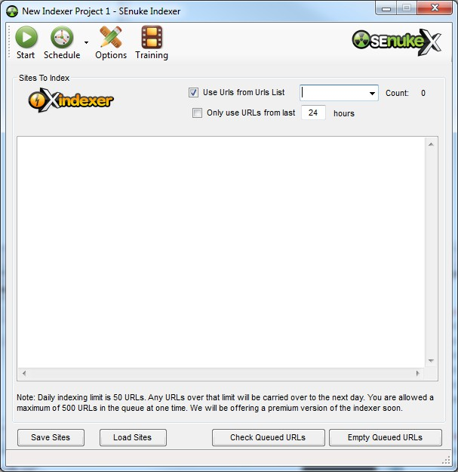
Tick the ‘Use Urls from Urls List’ box and in the drop down box select ‘Global SMTP Urls’, which is the output URLs from our ‘Social Network’ nuke created in Step 2.
Then again click schedule, and as before set this to start after the last project, in this case after the RSS project.
If you like you can repeat this Step 5 again to run your bookmarking accounts through Indexer as well, alternatively you could have the bookmarking module add its links to the same links list as we used in Step 2 Social Network. However while that would be OK for a small project like this you will easily get in a mess running large projects that way.

Step 6 Lastly Article Nuke
This is actually one of my favourite areas of SEnuke, mainly because of the amount of money I have made directly from articles published through it. Now one of the problems with article sites is many of them require a human review before they will allow your article to published there. If we were using spun content we would have a major problem. However because we are using quality content you will find that in most cases your articles is accepted, even if its duplicate content. There are exceptions to this of course, you will not get an article on Ezine by using another article you copied from Ezine (or anywhere else on the Internet!).
Article Nuke is much like Social Network nuke, so once again go to new and this time select Article Directory:
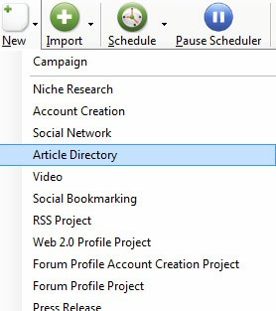
Open up the Article Directory project you just created and we will be setting the screen up like:
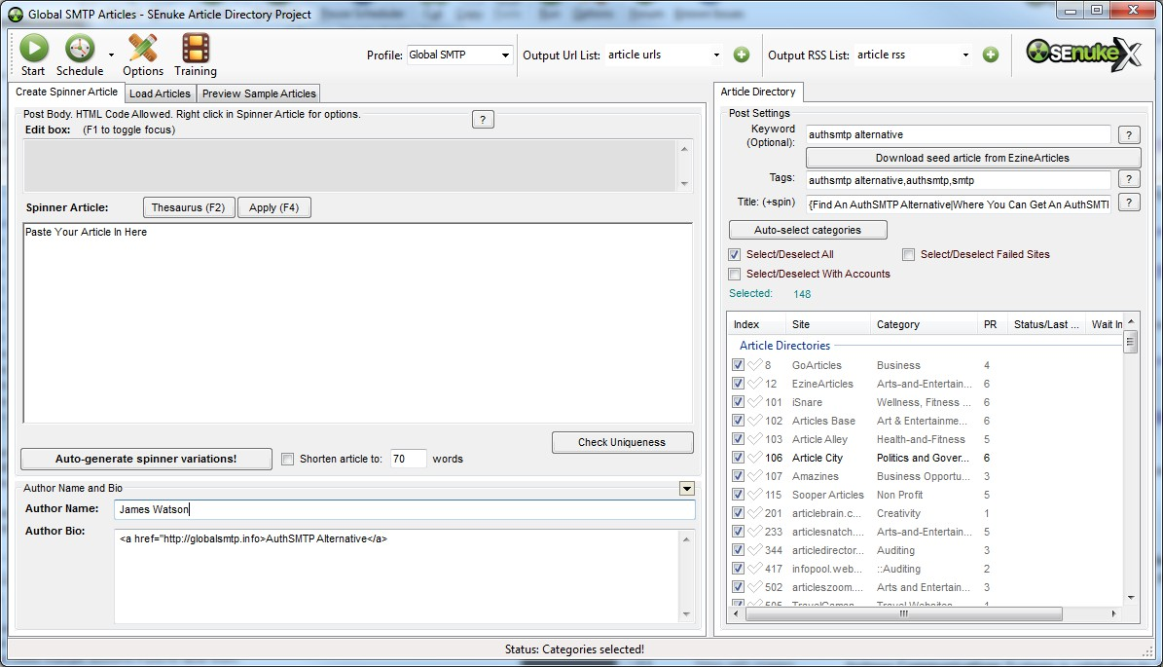

At the top select ‘Global SMTP’ as the profile, this remember is where all created accounts will be stored, then just as before click the + signs next to ‘Output URL List’ and ‘Output RSS List and enter names for those lists. Now one thing to note with Article Directory nuke is that is does not actually record very many entries in these lists, because many of the sites require a manual review before your article is published. At present SEnuke does not have the ability to go back and check the published status of your articles. In theory this should be quite an easy task to do, so keep pestering Areeb and the design team to add it!
Now put your article into the ‘Spinner Article’ area, even though we are not going to spin it. Add in your tags and title, exactly the same as we did in Social Network nuke, use the ‘Auto-select categories’ the same as we did for ‘Bookmarking Nuke’ and tick ‘Select/Deselect All.
Now the links, most article sites do not allow you to put links in the articles themselves, though a number of them do. So it’s up to your if you want to add links in the article and ‘risk it’ or just add links in the ‘Author Bio’ section. Now it’s a peculiarity of SEnuke X that while you can add links in the article using the ‘right click’ ‘add links to selected anchor’ method as we used in Social Network nuke you can’t do this in the Authors Bio box! So if you want to add a link there, which is the accepted place for your link on article sites, you will need to use a little bit of HTML.
In this case our link would be:
<a href="http://globalsmtp.info>AuthSMTP Alternative</a>
If that makes no sense to you then create a link in the ‘spinner article’ section the same as we did in Social Network nuke and then <cut><paste> it in to the Autho Bio section. If you can’t think of anything to write in this section you will probably get away with something generic like:
James Watson is a father of two and owner of GlobalSMTP, an <a href="http://globalsmtp.info>AuthSMTP Alternative</a>
Don’t forget also to fill in the author name field.

Lastly you can schedule this nuke exactly the same as you have done with the others. This time it will be running after the Indexer has finished.
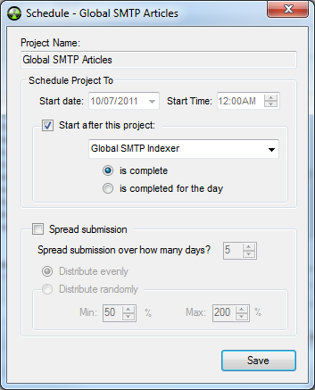

Job Done!

Time To Nuke
You have no setup an entire Nuke by hand You are just about ready to go!
Just to check your main SEnuke X control panel should look a little something like this….
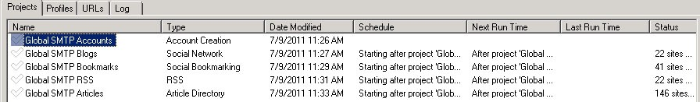
If yours looks like this then you are ready, you should may or may not have the Indexer module, which we called ‘Global SMTP Indexer’ depending upon whether you have a full or free trial license.
To start your nuke now click on ‘Global SMTP Accounts’ and then in the top menu press

Also make sure that the Resume scheduler button is pressed and not paused. It should look like the picture below.


The schedule checker should also be running, counting down constantly in the bottom right hand corner of SEnuke X.

If everything has been setup correctly then you should be seeing something like this:
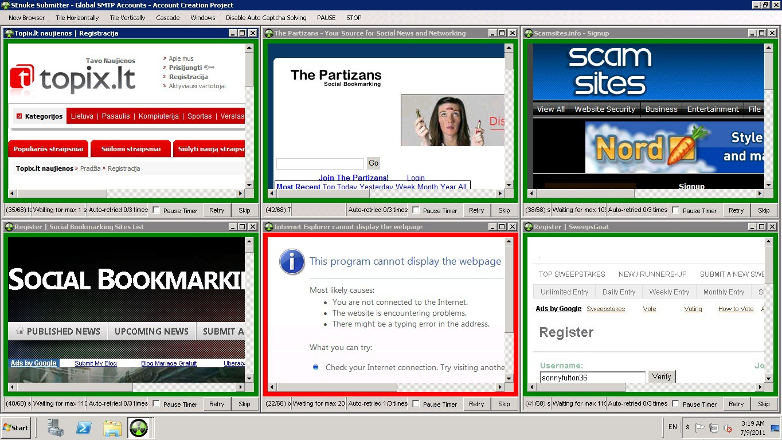
Here you can see 6 windows running, though if you have followed this guide exactly you will have only 4 running. Why did we have you set this so low? Well the most common problem with SEnuke X is the way it interfaces with Internet Explorer, the more browser windows you have open the more likely it is to fail at any one time.
At the moment SEnuke X is being converted from browser automation to sockets based. The Article Directory nuke is already converted, and as such you will not see the windows above when it is working. Sockets based nuking is much faster than browser automation, and also much more stable.
That’s it for the basics on setting up a simple SEnuke X campaign for backlinks.
There are lots more tutorials that will show you how to do some far more advanced things with SEnuke X and they can be found inside www.senuke-x.info.

